Artwork

1. Architecture sketching of Bangunan Sultan Abdul Samad

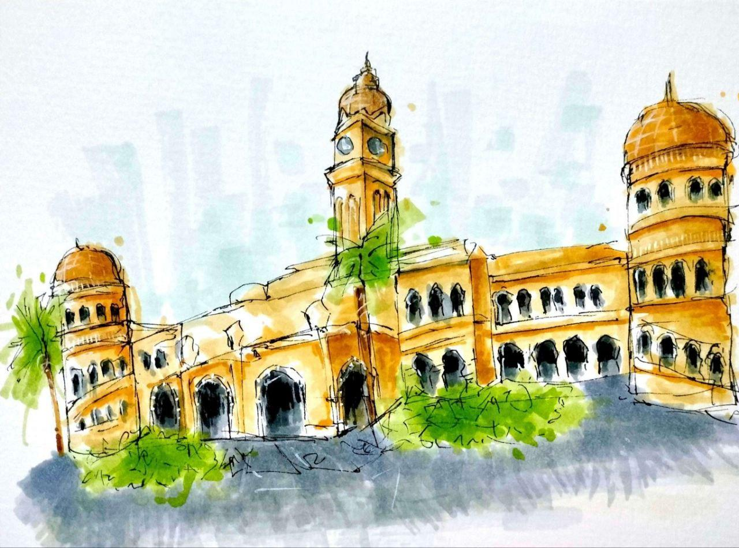

1. Cover book of The Walking Dead

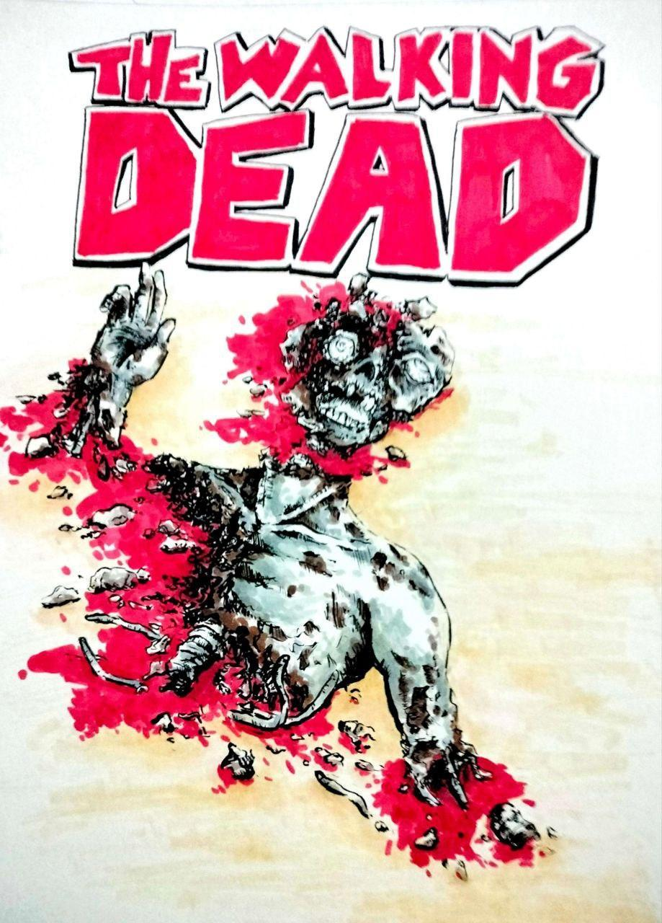

1. The Dark Side of Naga Tasik Chini

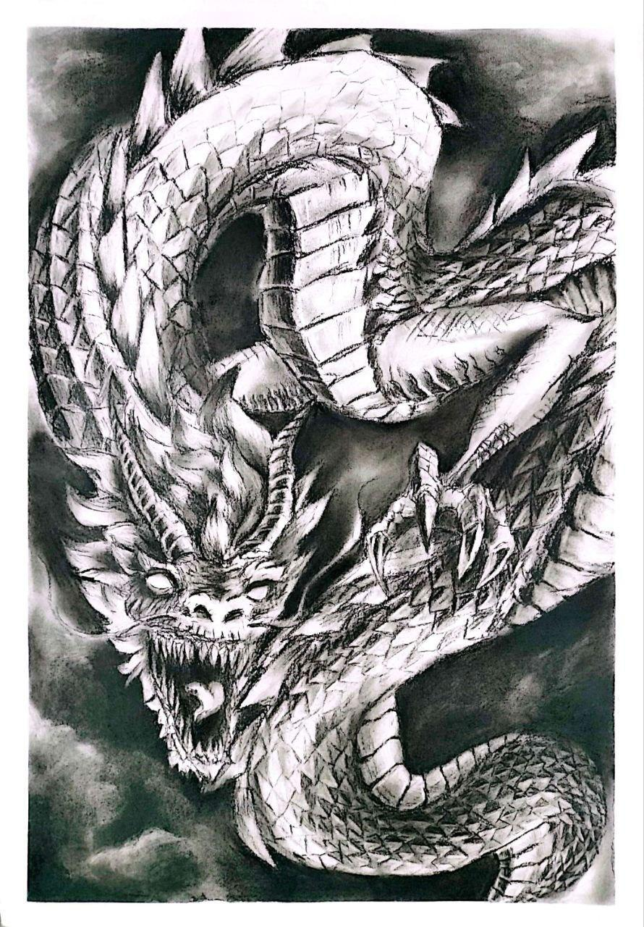

1. A fusion beast of tiger and deer

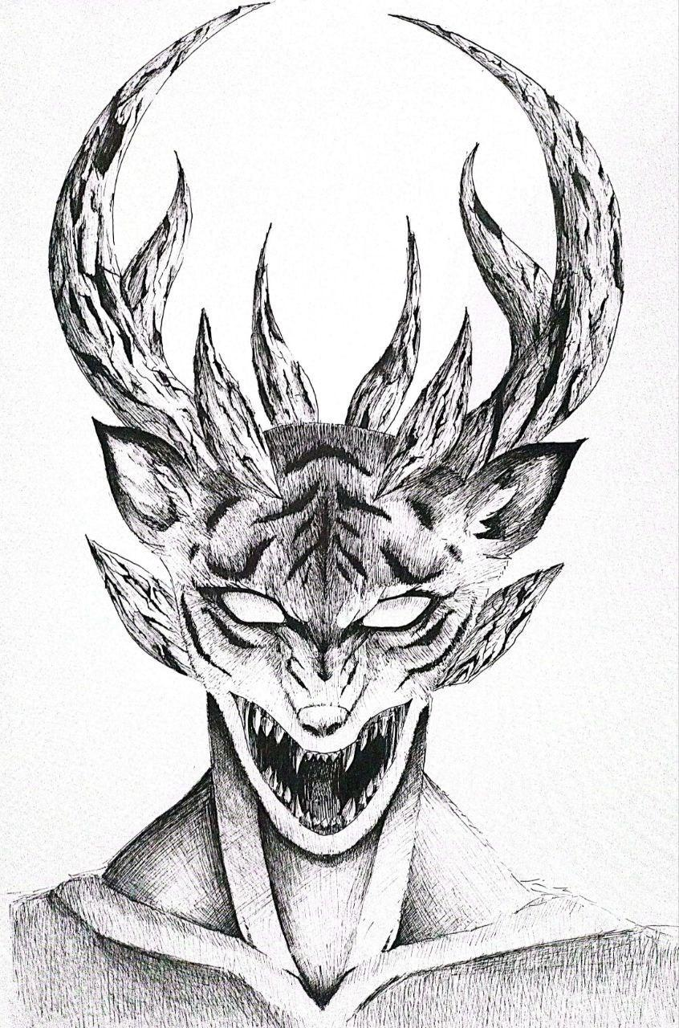

1. The survivor

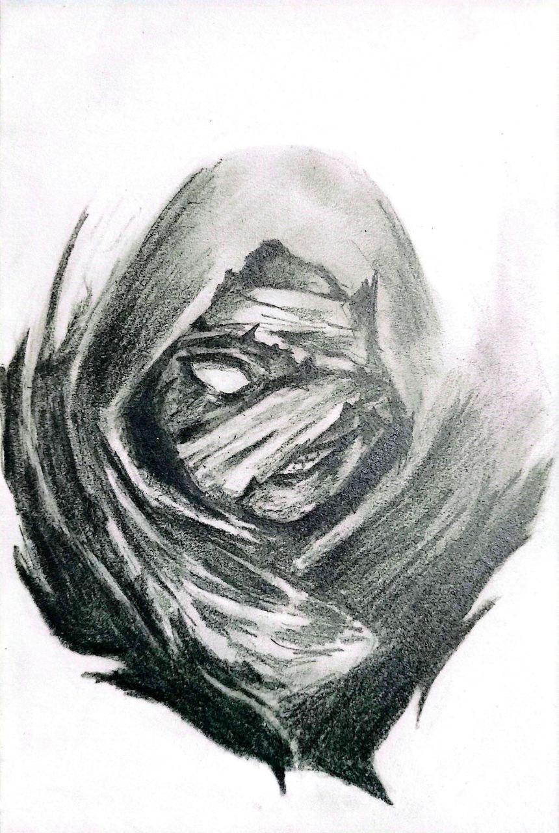

-1 favourite quote

Keep living, you haven’t achieved it yet

-short bio (50-150 words max)

I don’t even know who I am anymore. I’m a student working through deadlines. Some days I feel like I’m making progress, others I’m just exhausted. But I keep drawing, animating, and moving forward, even if I don’t always know where I’m headed. Maybe that’s just what growth looks like.

- socmed handle or email

Email: sofialina238@gmail.com